Back Office Tools Finex Distribution Manual

Contents

Revision history 2

1. Business flow description 3

2. Folders 3

3. Input file 4

4. IsinsWithoutHolders file 5

5. IsinsWithHolders file 7

6. IsinsNotFound file 8

7. Archive 8

8. Errors 9

9. Troubleshooting 10

# Revision history

|  |  |  |  |  |
| --- | --- | --- | --- | --- |
| **Date** | **Version** | **Author** | **Reason for Change** | **Approved by** |
| 03/11/2017 | V1 | Paweł Turek | First draft |  |
| 03/11/2017 | V2 | Dominik Niszewski | Review and minor changes |  |
| 03/11/2017 | V3 | Arkadiusz Pękacz | Review |  |
| 14/11/2017 | V4 | Paweł Turek | Minor changes |  |

## Business flow description

Back Office Tools starts processing when a file has appeared in “FromFinexDist” folder (i.e. put there by $Universe or manually copied). This folder is monitored by a file watcher. Once the file has been detected, it is moved from the folder and the processing starts. In positive scenario each ISIN is checked against ODS database and each record is put in one of three output files (IsinWithoutHolders, IsinWithHolders and IsinsNotFound). Then output files are placed in ”ToSonata folder” and “Archive folder”. The Input file is also archived.

When an error appears, then the input file and the output files if exist are stored in error folder. Nothing is archived and error logs are created.

## Folders

Structure of the folders for Finex Distribution:

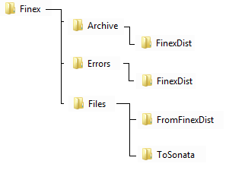

There are 4 folders which are used by Back Office Tools:

* \\…\Finex\Archive\FinexDist – in this folder Back Office Tools puts archived files
* \\…\Finex\Errors\FinexDist – in case errors occur, files and logs are placed there
* \\…\Finex\Files\FromFinexDist – this folder is watched and when a file appears, then Back Office Tools starts to process
* \\…\Finex\Files\ToSonata – place where output files are created (with no holders, with holders and not found isins)

Important: Each instance of Back Office Tools has different location of mentioned folders. It means that on each environment there is a separate folder structure. Path to these folders is configurable in code in tokens.

File IFDL\Acc\Main\_vNext\Deploy\Tokens\tokens.xml (here is global configuration of folders name):



Values for ##Subtoken_FileServer## and for ##ENV## which are place for folders are configured for each environment in file ”IFDL\Acc\Main\_vNext\Deploy\Tokens\XXX” (where XXX is an environment name i.e. TSH)

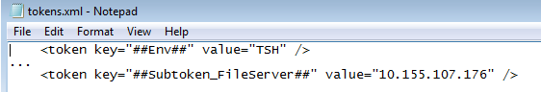

As it is configured as above. The full path on TSH for Finex Distribution folder is:

* \\10.155.107.176\AcceleratorTSH\Finex\Archive\FinexDist
* \\10.155.107.176\AcceleratorTSH\Finex\Errors\FinexDist
* \\10.155.107.176\AcceleratorTSH\Finex\Files\FromFinexDist
* \\10.155.107.176\AcceleratorTSH\Finex\Files\ToSonata

## Input file

The input file is a CSV file which contains basic information about dividends related to assets. This file needs to have a specific format. Otherwise it cannot be successfully processed by Back Office Tools. A sample of input file is displayed on screenshot below:

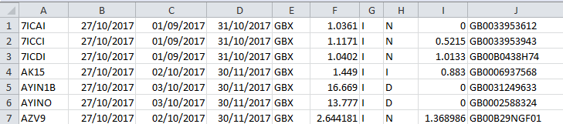

Each column contains different value type:

1. Column A - Finex Asset code
2. Column B - Received date
3. Column C - Ex Date
4. Column D – Pay Date
5. Column E – Currency
6. Column F - Group 1 rate
7. Column G - Distribution type (interim or final)
8. Column H - Income Stream (dividend, interest or other)
9. Column I - Equalisation rate
10. Column J - Asset ISIN code

Requirements and basic information about input file:

* File should be in CSV format
* File name is not validated
* File should have columns and value types as listed above
* Back Office Tools processor uses two columns (Column C – Ex Date, Column J – Asset ISIN code)
* Columns A, B, D, E, F, G, H, I are not used by Back Office Tools for any calculation or filtration. These values are only moved to 2 out of 3 output files without any changes
* Back Office Tools cannot process a file in input folder if it is opened in an external tool (Word, Notepad, etc…), because opening the file will result in Back Office Tools not being allowed to process the file
* In case more than one file appears at the same time, then Back Office Tools will start to process these files in queue one by one

## IsinsWithoutHolders file

First of output files is the IsinsWithoutHolders file. It contains data for dividends for assets with no holders. Back Office Tools takes all assets from the input file and queries ODS database table. All assets which are available in ODS Fund table and **don’t** fulfil the condition below are placed in this file:

SELECT f.FUND_SHORT_NAME, p.PARCEL_STATUS, p.CANCEL_DATE, p.EFFECTIVE_DATE, p.*

FROM [ODS].[dbo].[FUND] as f

join ODS.dbo.Parcel as p

on f.FUND_ID = p.FUND_ID

where P.EFFECTIVE_DATE <= 'file_XD-1'

AND (p.PARCEL_STATUS !='VOID' and (p.CANCEL_DATE is null or p.CANCEL_DATE >'file_XD-1'))

Order by p.CANCEL_DATE desc

Summarizing, Back Office Tools puts in this file only ISINs from input file which exist in Fund table, but don’t have any Parcel on the time ExDate -1. File should look like that:

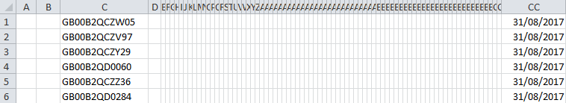

Below is the same file but opened in Notepad (only for better understanding that there are many empty columns and only two are filled).

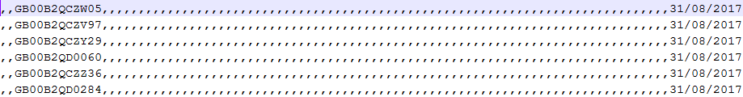

Information about file produced by Back Office Tools:

* Columns A and B should always be empty
* Column C (ISIN Short Name) is ISIN taken from input file from Column J (Asset ISIN code)
* Columns from D to CB should always be empty
* Column CC (Last Income Dist Date) is a date taken from input file from Column C (Ex Date) -1 (minus one day)
* Column CC is the last column in the file
* It is very important to remember that in this file there are only assets without holders
* Created only when there is at least one asset qualified for this file
* File needs to be placed in Archive folder and ToSonata folder
* Name of the file is FinexDistribution_IsinWithoutHolder.csv

(in case when a file already exists in the output folder, then another file is created with name FinexDistribution_IsinWithoutHolder_X.csv where X is sequent number)

More information about mentioned fields and required file by Sonata is available on [Bravura Wiki.](https://wiki.bravurasolutions.com/pages/viewpage.action?spaceKey=CliAsc&title=Asset+Maintenance+Upload)

## IsinsWithHolders file

Second of output files is the IsinsWithHolders file. It contains data for dividends for assets with holders. Back Office Tools takes all assets from input file and queries ODS database table. All assets which are available in ODS Fund table and fulfil condition below are placed in this file:

SELECT f.FUND_SHORT_NAME, p.PARCEL_STATUS, p.CANCEL_DATE, p.EFFECTIVE_DATE, p.*

FROM [ODS].[dbo].[FUND] as f

join ODS.dbo.Parcel as p

on f.FUND_ID = p.FUND_ID

where P.EFFECTIVE_DATE <= 'file_XD-1'

AND (p.PARCEL_STATUS !='VOID' and (p.CANCEL_DATE is null or p.CANCEL_DATE >'file_XD-1'))

Order by p.CANCEL_DATE desc

Summarizing Back Office Tools puts in this file only ISINs from input file which exist in Fund table and have Parcel on the time ExDate -1. File should look like that:

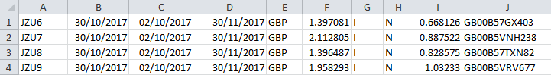

Information about file produced by Back Office Tools:

* In this file there are only ISINs from input file which have holders
* Created only when there is at least one asset qualified for this file
* In case when ISIN is qualified for placing in this file, then the whole row without changes is moved. It means that columns, the order of columns is the same as in input file
* File needs to be placed in Archive folder and ToSonata folder
* Name of the file is FinexDistribution_IsinWithHolder.csv

(in case when a file already exists in output folder, then another file is created with name FinexDistribution_IsinWithHolder_X.csv where X is sequent number)

## IsinsNotFound file

This file contains only ISINs which are not available in ODS Fund table and is created only for information purpose. When an asset from the input file is not recognized, then the whole row is moved into this output file. In case all ISINs are available on ODS, then this file is not created.

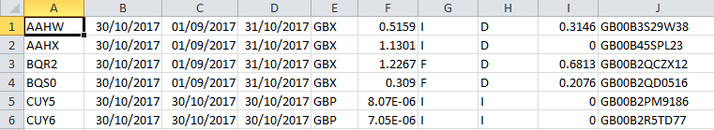

Information about the file produced by Back Office Tools:

* In this file there are only ISINs which are not available on ODS
* This file is only created when there is at least one asset which is not found on ODS
* In case ISIN is qualified for placing in this file, then the whole row without changes is moved. It means that columns, order of columns is the same as in input file
* File needs to be placed in Archive folder and ToSonata folder
* Name of the file should be FinexDistribution_IsinNotFound.csv

(in case when a file already exists in output folder, then another file is created with name FinexDistribution_IsinNotFound_X.csv where X is sequent number)

* This file should not be processed by Sonata

## Archive

Archive folder is a place where file are saved in case the process is successfully finished. When there are any errors, then no files will appear in this folder. Basic information about Archive:

* Files appear only when process is successfully finished
* Input file and output files (two or three) are archived
* Each file should be renamed to DateStamp_NameOfFolder_OriginalFileName.csv (i.e. “20171102094714011_ToSonata_FinexDistribution_IsinNotFound.csv”)

## Errors

Finex Distribution has no specific error handling and if any errors appear, they will be handled by general Back Office Tools mechanism. In case of any error during processing, file/files are moved to Error folder and additional log file is created. Basic information about Errors:

* Files appear only when process is finished with errors
* Input file and output files (if they exist, because error could occur before any output file is created) are stored in errors folder
* Each file should be renamed to DateStamp_NameOfFolder_OriginalFileName.csv (i.e. “20171102094714011_ToSonata_FinexDistribution_IsinNotFound.csv”)

Logs are stored in three places:

* Log file in error folder – created in case of error with basic information about the problem
* BackOfficeInternal database in logging.log table – this table contains the same error messages in some cases with extended information
* Windows event log – required for investigating problem with Back Office Tools service. These logs are created only on a machine where Back Office Tools service is running.

Samples of errors:

* “FormatException : String was not recognized as a valid DateTime.” – it means that in input file there is some string instead of correct DateTime
* “Message: Field at index 'X' does not exist.” – input file is incorrect – not enough columns
* “ERROR SqlServerPollingDequeueStrategy - An exception occurred when connecting to the configured SQLServer instance” – infrastructure problem, Back Office Tools could not connect to database

## Troubleshooting

|  |  |
| --- | --- |
| **Problem** | **To Do** |
| Back Office Tools doesn’t take the file | 1. The easiest way is trying to run a different process, like Calastone or Finex to check if Back Office Tools works at all 2. Verify if you use correct folders 3. Check all logs 4. Log in to Back Office Tools database and run query:   SELECT * from [BackOfficeInternal].[queuing].[Schedule]  where Type = ‘Accelerator.BackOfficeTools.BusinessLogic.FinEx.DistributionsFinExFeedToSonataTaskMessage, Accelerator.BackOfficeTools.BusinessLogic'  Verify if StatusId = 1 (if not, it needs to be investigated why there is different status and after that manually changed back to 1)   1. File could be opened in external program (i.e Notepad, Excel, …) than should be closed 2. Next check if Back Office Tools service works. It could be verified only by a person who has access to machine where Back Office Tools is installed. They need to check if in Services Back Office Tools service works and if there are no errors in Windows Event Log |
| There is no files in archive folder | 1. Verify if you use correct folders 2. Check all logs 3. Check error folders |
| There is no files in error folder | 1. Verify if you use correct folders 2. Check all logs 3. Check archive folder |